Health - Very Very Important Tips
Answer the phone by LEFT ear.
Do not drink coffee TWICE a day.
Do not take pills with COOL water.
Do not have HUGE meals after 5pm.
Reduce the amount of OILY food you consume.
Drink more WATER in the morning, less at night..
Keep your distance from hand phone CHARGERS.
Do not use headphones/earphone for LONG period of time.
Best sleeping time is from 10pm at night to 6am in the morning.
Do not lie down immediately after taking medicine before sleeping.
When battery is down to the LAST grid/bar, do not answer the phone as the radiation is 1000 times.
Forward this to those whom you CARE about!
Here are some healthy tip for your smartness & physical fitness.
Prevention is better than cure.
HEALTHY JUICES

Carrot + Ginger + Apple - Boost and cleanse our system.

Apple + Cucumber + Celery - Prevent cancer, reduce cholesterol, and eliminate stomach upset and headache.

Tomato + Carrot + Apple - Improve skin complexion and eliminate bad breath.
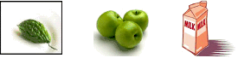
Bitter gou rd + Apple + Milk - Avoid bad breath and reduce internal body heat.
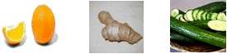
Orange + Ginger + Cucumber - Improve Skin texture and moisture and reduce body heat.
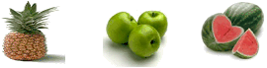
Pineapple + Apple + Watermelon - To dispel excess salts, nourishes the bladder and kidney.

Apple + Cucumber + Kiwi - To improve skin complexion.
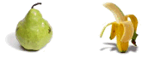
Pear & Banana - regulates sugar content.
Carrot + Apple + Pear + Mango - Clear body heat, counteracts toxicity, decreased blood pressure and fight oxidization .
Honeydew + Grape + Watermelon + Milk - Rich in vitamin C + Vitamin B2 that increase cell activity and str engthen body immunity.

Papaya + Pineapple + Milk - Rich in vitamin C, E, Iron. Improve skin complexion and metabolism.
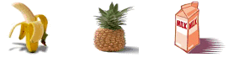
Banana + Pineapple + Milk - Rich in vitamin with nutritious and prevent constipation
Quite interesting!
Keep Walking.....
Jus to check this out......
The Organs of your body have their sensory touches at the bottom of your foot, if you massage these points you will find relief from aches and pains as you can see the heart is on the left foot.
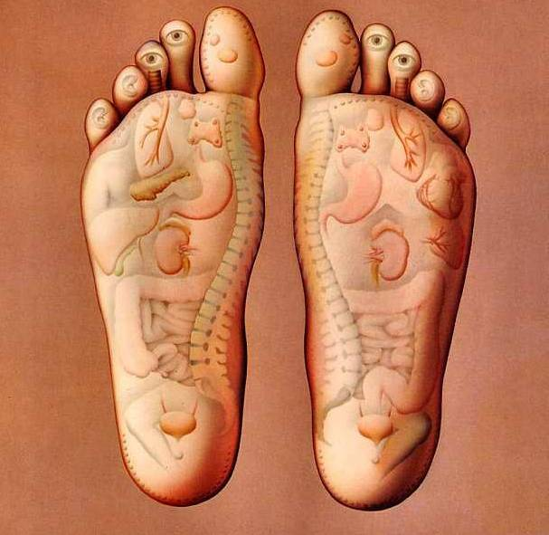
Typically they are shown as points and arrows to show which organ it connects to.
It is indeed correct since the nerves connected to these organs terminate here..
This is covered in great details in Acupressure studies or textbooks.
God created our body so well that he thought of even this. He made us walk so that we will always be pressing these pressure points and thus keeping these organs activated at all times.
So, keep walking....
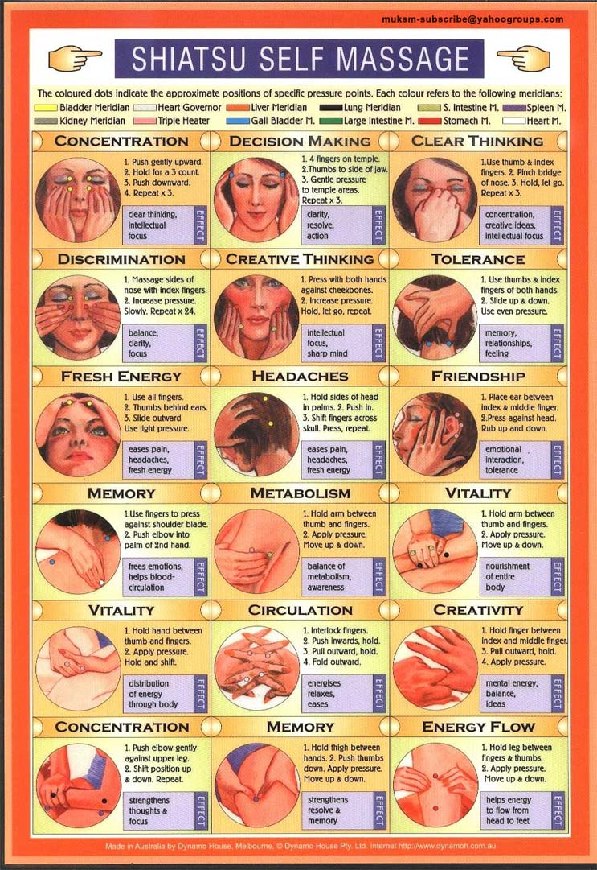
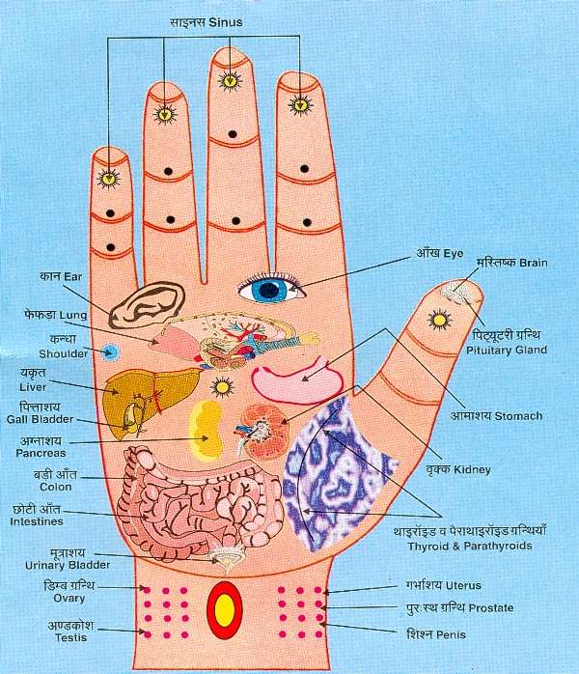
Good one. Don't miss the attachments
Did You Know?

Blood type and Rh | How many people have it?
O + | 40 %
O - | 7 %
A + | 34 %
A - | 6 %
B + | 8 %
B - | 1 %
AB + | 3 %
AB - | 1 %

Does Your Blood Type Reveal Your Personality?

Accord ing to a Japanese institute that does research on blood types, there are certain personality traits that seem to match up with certain blood types. How do you rate?

TYPE O | You want to be a leader, and when you see something you want, you keep striving until you achieve your goal. You are a trend-setter, loyal, passionate, and self-confident. Your weaknesses include vanity and jealously and a tendency to be too competitive.
TYPE A | You like harmony, peace and organization. You work well with others, and are sensitive, patient and affectionate. Among your weaknesses are stubbornness and an inability to relax.
TYPE B | You're a rugged individualist, who's str aightforwa rd and likes to do things your own way. Creative and flexible, you adapt easily to any situation. But your insistence on being independent can sometimes go too far and become a weakness.
TYPE AB | Cool and controlled, you're generally well liked and always put people at ease. You're a natural entertainer who's tactful and fair. But you're standoffish, blunt, and have difficulty making decisions.

REGARDS, MANIKANDAN,
You Can Receive
If Your Type Is | O- | O+ | B- | B+ | A- | A+ | AB- | AB+
AB+ | YES | YES | YES | YES | YES | YES | YES | YES
AB- | YES |  | YES |  | YES | YES
A+ | YES | YES |  |  | YES | YES
A- | YES

